- We expect the Bank of England's Monetary Policy Committee to cut Bank Rate by 25bps at next week's meeting. As in November, Catherine Mann is likely to be the sole dissenter.
- The MPC will likely revise up its near-term inflation forecast due to higher energy and oil prices, and a weaker pound. But higher inflation and market interest rate expectations will lead the MPC to cut its growth forecast, with its 2025 projection likely to drop below 1%.
- We will be looking closely at the MPC's medium-term inflation forecast for signals on the rates outlook. In keeping with the more dovish messaging from December's meeting and given the limited easing built into the market curve, we expect the MPC will forecast inflation to slip below its target two years out and fall further in year three. This would be consistent with our call that Bank Rate will be cut by at least 100bps in 2025.
The Bank of England's Monetary Policy Committee has been following a 'cut-hold' tempo since the rate-cutting cycle kicked off last summer. We regard another 25bp cut at February's meeting as almost a certainty. Financial markets agree, pricing a 92% chance of a 25bp cut next week.
From our perspective, the more important issue is the MPC's signalling about where we go from here. The messaging from December's meeting was surprisingly dovish, with three members voting for back-to-back cuts and the majority expressing concerns about the weakness of output and employment. However, financial markets have become markedly more hawkish over recent months, largely in response to news from the US. As a result, the MPC's new forecast is likely to be based on market interest rate expectations that are around 40bps higher than when the MPC presented its previous forecast in November (Chart 1).
In the minutes of December's meeting, the MPC placed less emphasis on its three inflation scenarios. Rather, the commentary made it clear that after being heavily focused on upside inflation risks in recent years, with little emphasis on downside growth risks in its decision-making, the committee is increasingly thinking about the implications of recent weakness in activity and employment.
Chart 1: Markets have become more hawkish since the MPC's last forecast in November
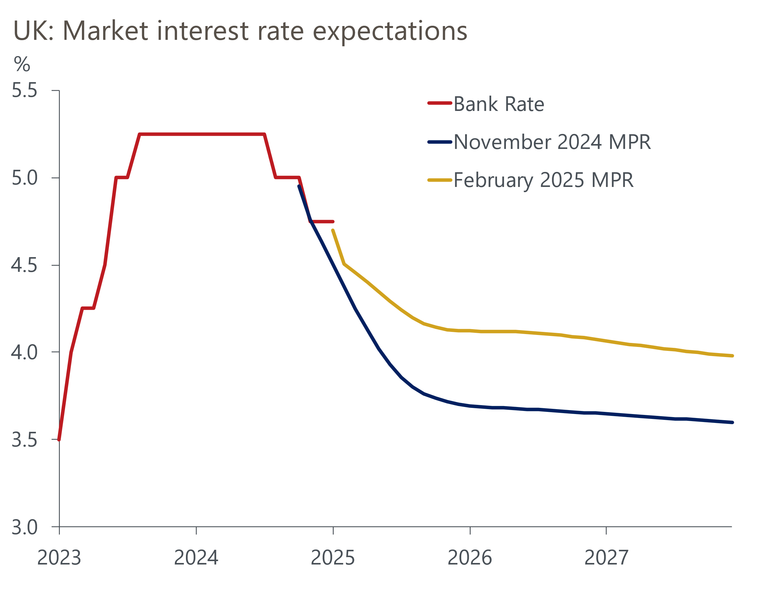
Source: Haver Analytics

Recent data offered mixed messages on the inflation outlook
Little data have been published since the December meeting. And what modest news we've had has been ambiguous for the MPC. Regarding the near-term inflation outlook, we largely discount the importance of December's downside surprise for services inflation. It was almost entirely due to quirks in the collection dates for data in two volatile categories – air fares and accommodation services – and there's a good chance these impacts will unwind next month. Equally, the recent pickup in private sector regular pay growth was heavily linked to base effects and composition effects. Our sentiment data-based nowcast, developed with Penta, has been softer, stabilising at around 4.5% at the turn of the year (Chart 2).
Chart 2: Our nowcast suggests pay growth has stabilised around 4.5%
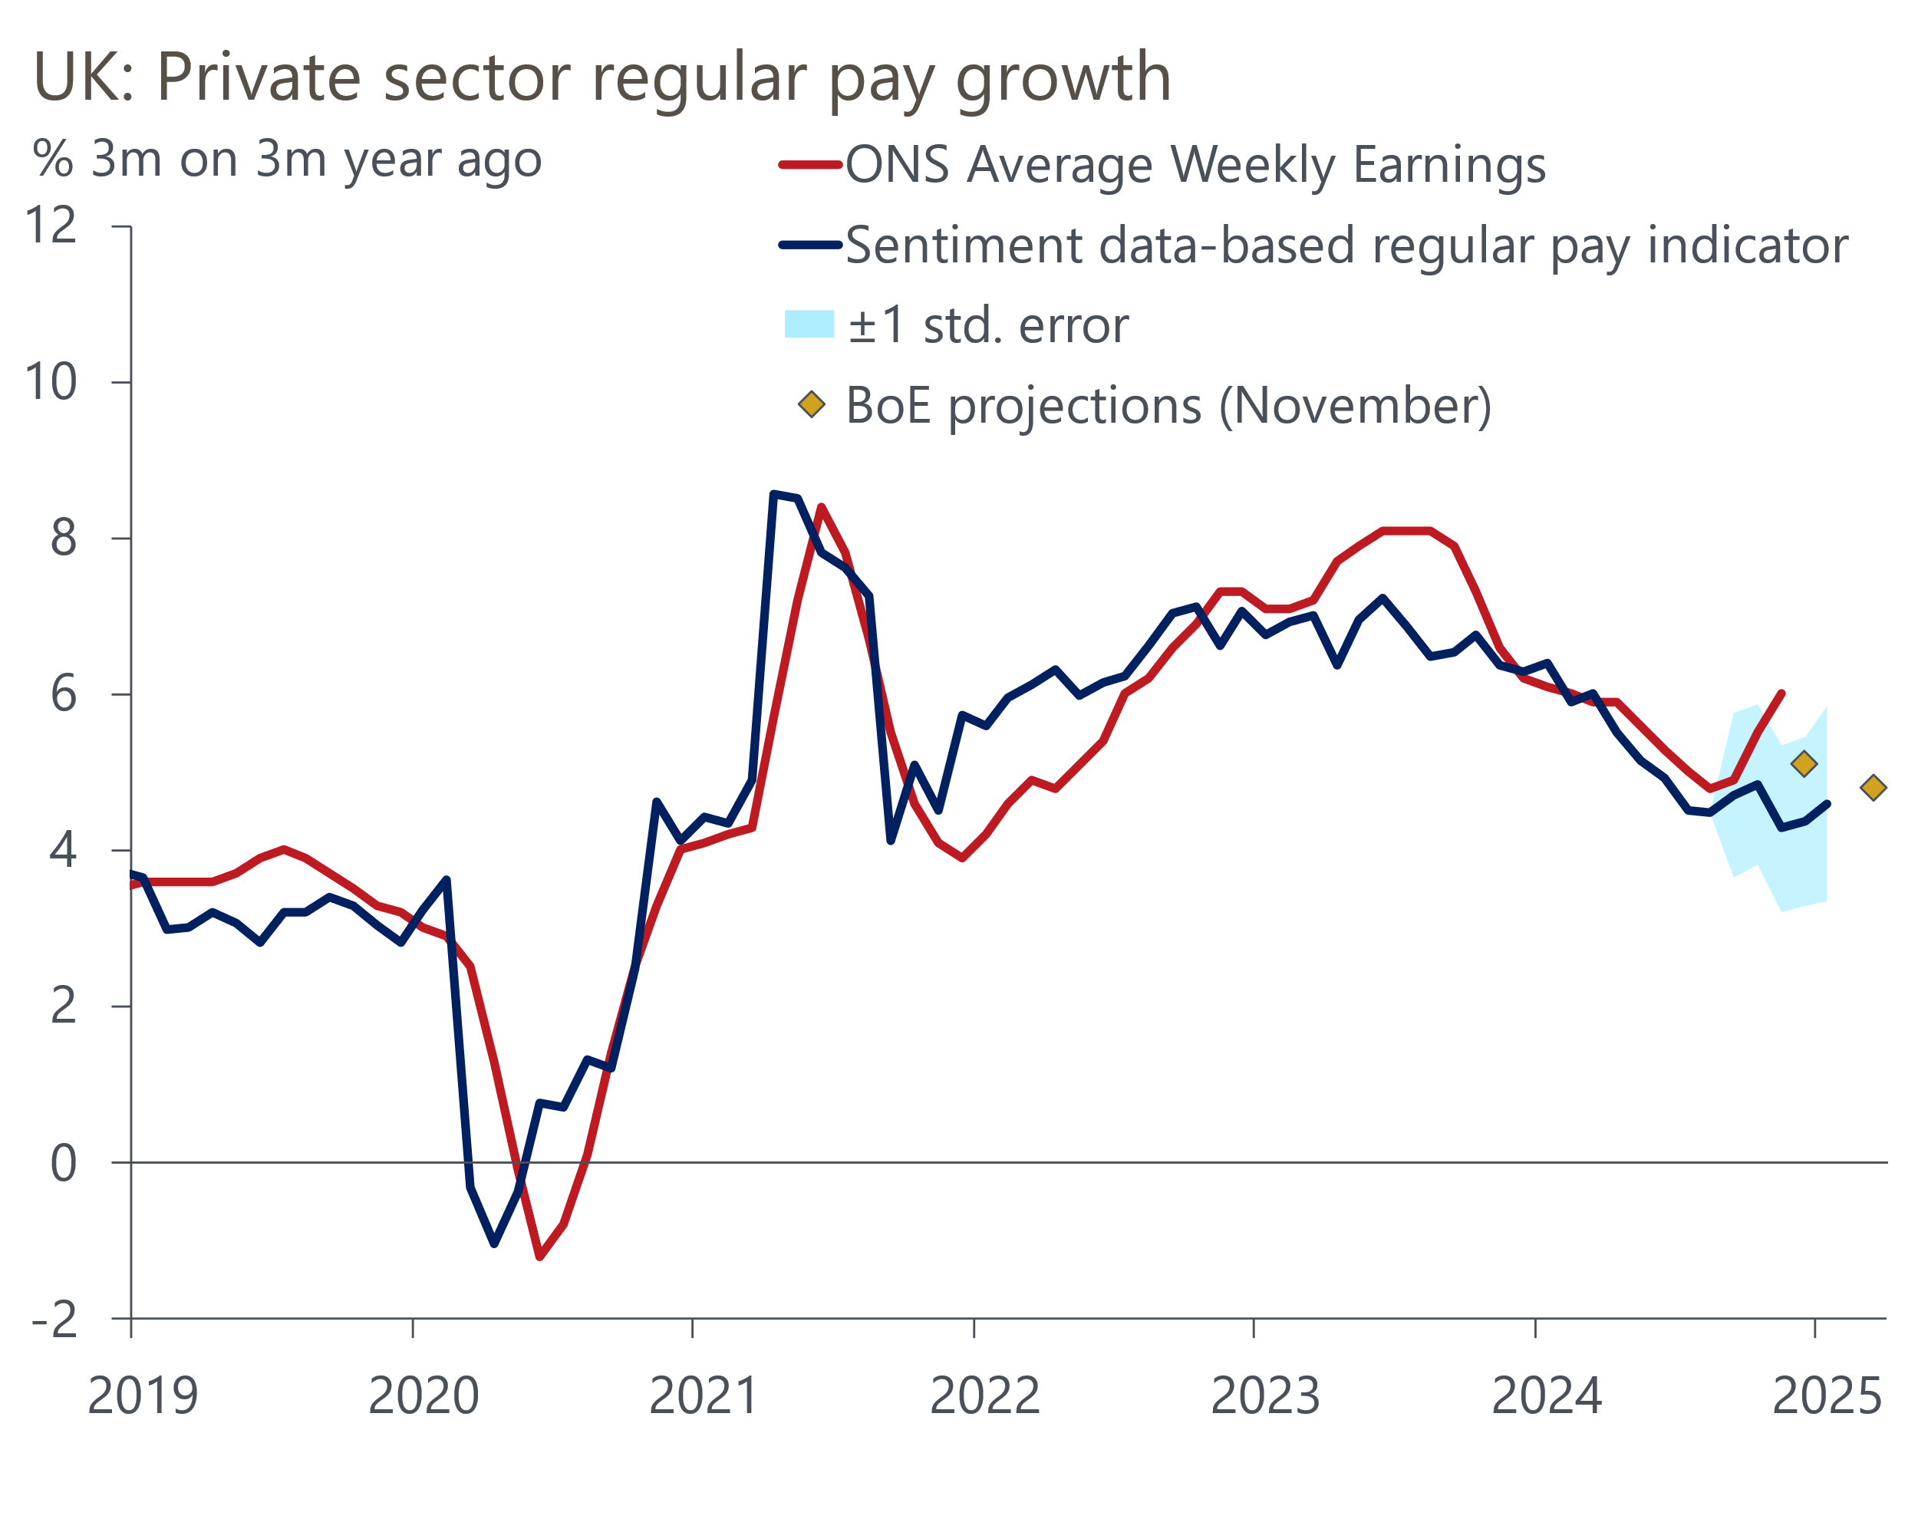
Source: Oxford Economics/Penta/Haver Analytics
The key question for the MPC is where pay growth will go from here. The softer pace flagged by our nowcast is still some way above the pace that the BoE considers consistent with achieving its inflation target over the medium term. It's also slightly higher than the top of the range of potential outcomes recently identified by the BoE's regional agents. The MPC will see an update of this market intelligence ahead of the February meeting, and this will likely be a key influence on its views.
Beyond the near term, the MPC's view on the evolution of pay growth will be driven by its view of labour market conditions more broadly. As we argued in a recent note, a loss of faith in the Office of National Statistics' Labour Force Survey is a major problem in this respect, increasing the uncertainty around the MPC's decision-making. April's increases in employers' national insurance contributions and the national living wage compound those uncertainties.
But other data should leave the MPC cautiously concluding that labour market conditions are loosening, and that this should increasingly bear down on pay growth. Job vacancies continue to drift lower and are now broadly in line with pre-pandemic levels. Meanwhile, our nowcast suggests that year-on-year employment growth has slowed to zero. But redundancies remain quite low, suggesting that firms are still keen to hold onto staff, if possible, with any headcount reduction largely occurring due to leavers not being replaced.

MPC likely to use its forecast to signal further rate cuts ahead
Signs that labour market conditions are still loosening and concerns that soft activity might further weaken demand for labour, are likely to mean all members except Catherine Mann vote to cut Bank Rate at next week's meeting. We also expect the tone of the BoE's communications to be dovish. As well as a comprehensive vote, we envisage the minutes to repeat December's concerns about recent soft activity and employment data, and to again state that "a gradual approach to removing monetary policy restraint remained appropriate".
The dovish signal will be strengthened by the MPC's new forecasts. In November, the MPC explicitly tied its central forecast to the mid-range inflation scenario for the first time. We expect the new forecast to follow this practice, even though it's clear that at least three members – Swati Dhingra, Dave Ramsden, and Alan Taylor – think that the most benign scenario is at least as likely.
Large financial market moves and recent downside surprises for activity mean there will be many moving parts to the MPC's forecasts. Gas, electricity, and oil prices have risen significantly over the past three months. The impact on the MPC's inflation forecasts will be compounded by the weakness of sterling, particularly for those imported goods that are priced in US dollars. For example, the average price implied by oil futures for H1 2025 will be around 6% higher than the assumption underpinning November's forecast, while sterling has depreciated by 6% against the US dollar (Chart 3). This is likely to mean that the MPC's 2025 inflation forecast rises close to our forecast of 3%, from 2.75%.
Chart 3: The MPC's new forecasts will assume higher sterling oil and energy prices
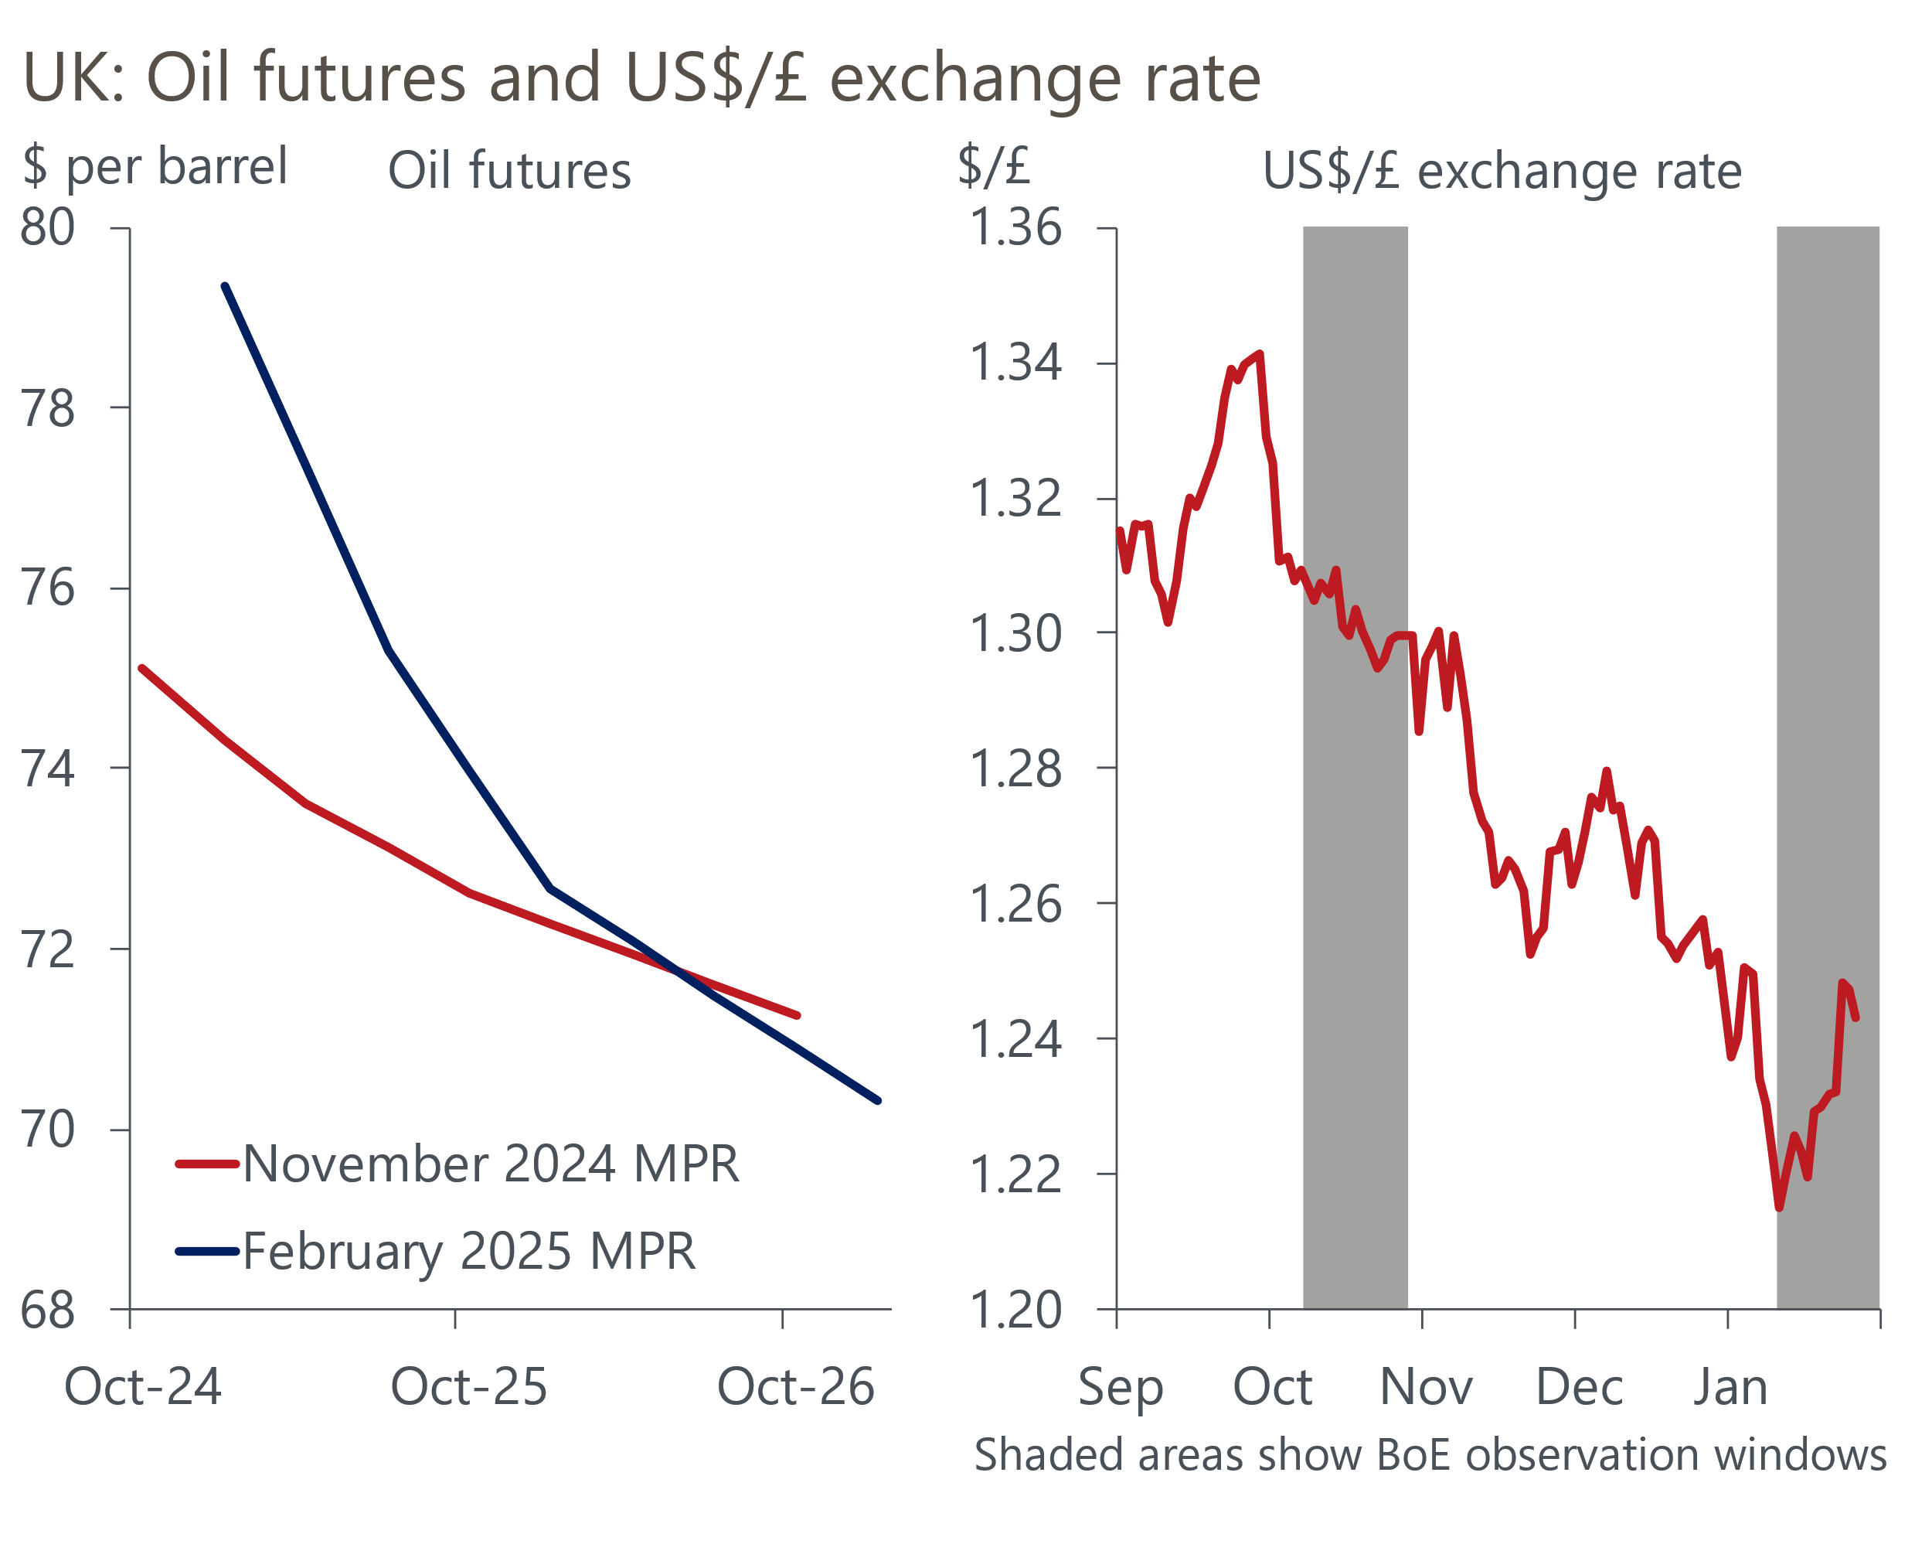
Source: Oxford Economics calculations using data from Haver Analytics
But higher inflation will erode real wages and, hence, weigh on the growth outlook, compounding the carryover effect of the disappointing end to 2024. So it's likely that the MPC's 2025 GDP growth forecast will drop below 1%. And for 2026, the drag on growth from higher inflation will be supplemented by the impact of a market curve for Bank Rate that's around 40bps higher than in November (Chart 1).
That the MPC will also conduct its annual stocktake on the supply side means it's hard to gauge the impact of weaker growth on the MPC's forecasts for spare capacity. But considering its recent commentary, we think the new forecasts will show a greater degree of spare capacity emerging. This, in turn, implies a lower inflation forecast in the latter half of the forecast. We think the MPC's new forecast will show inflation below 2% at the two-year horizon, dropping further in the third year.
This would send a clear message that the MPC expects to continue to steadily loosen monetary policy this year. Our baseline forecast assumes that the cut-hold tempo is maintained throughout 2025, with cuts in February, May, August, and November, and rates falling further next year. We view a scenario where a bigger shake-out in the jobs market encourages the MPC to speed up the pace of rate cuts this year as being more likely than the current market path, which implies around 70bps of rate cuts in 2025.

